**EXPERIMENT-2**

**Design a Solar Water Heater using SAM Software**

**AIM:** Design a SWH system and assess the annual energy saved for a varying water demand of 50 l/day to 300 l/day (interval of 50 l) for a single collector costing Rs. 160000 (2000$) for location as discussed during the session. Calculate the LCOE and Capacity factor for varying water demand and plot the results (w.r.t. varying water demand). Working fluid is water. Discuss the trends of LCOE, Capacity factor and annual energy saved as a function of water demand. Also, compare how these performance indexes change when the number of collectors is increased to 2 (for water demand = 300 l/day). Attach the screenshots of each step in your report and present a good discussion of the results.

**Location:**

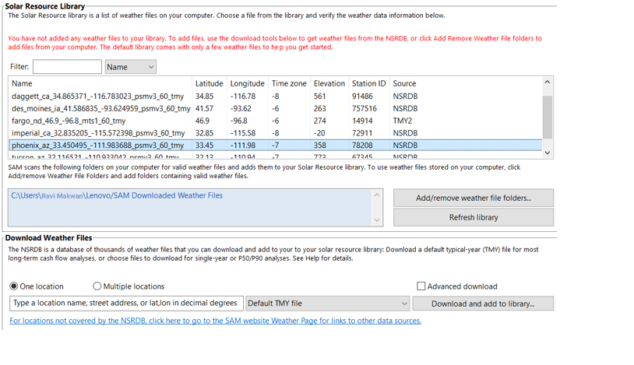

**Whether File:**

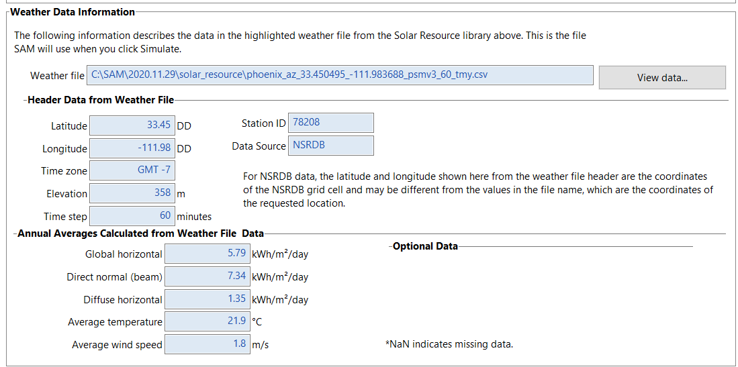

**For 1 collector:** Demand: 50 l/day

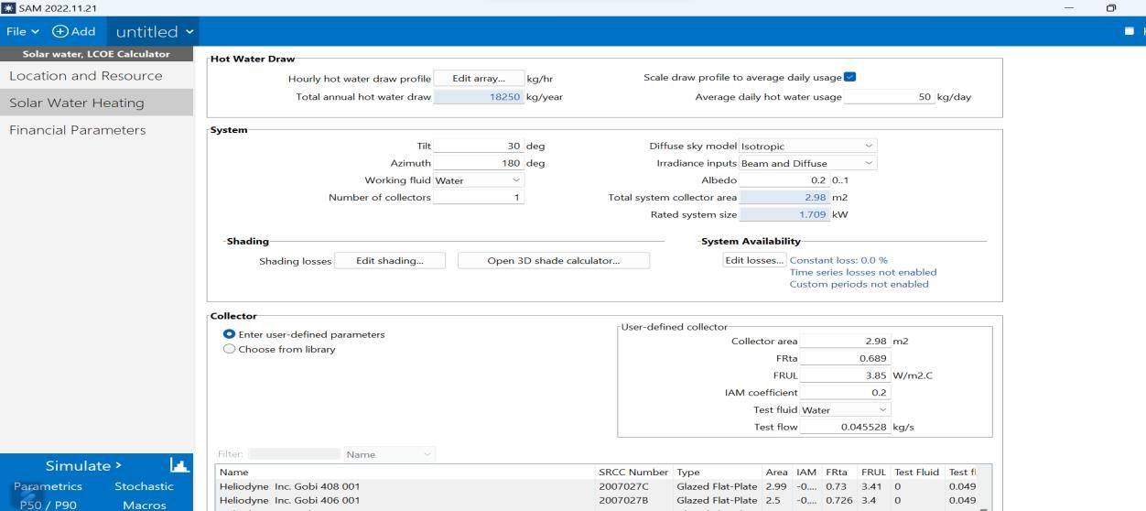

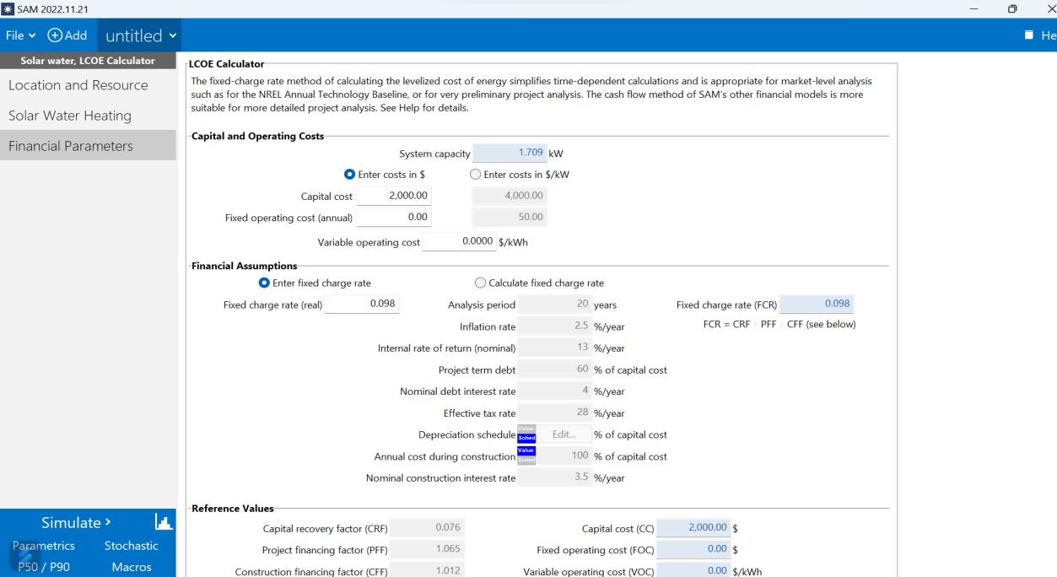

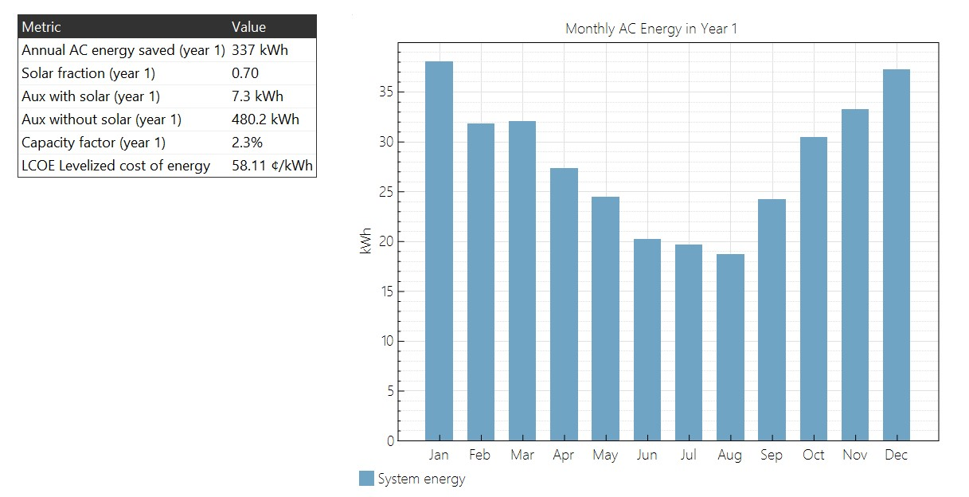

Demand: 100 l/day

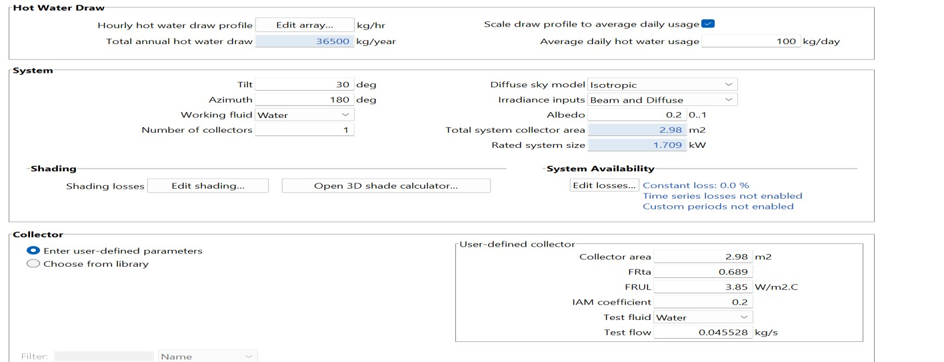

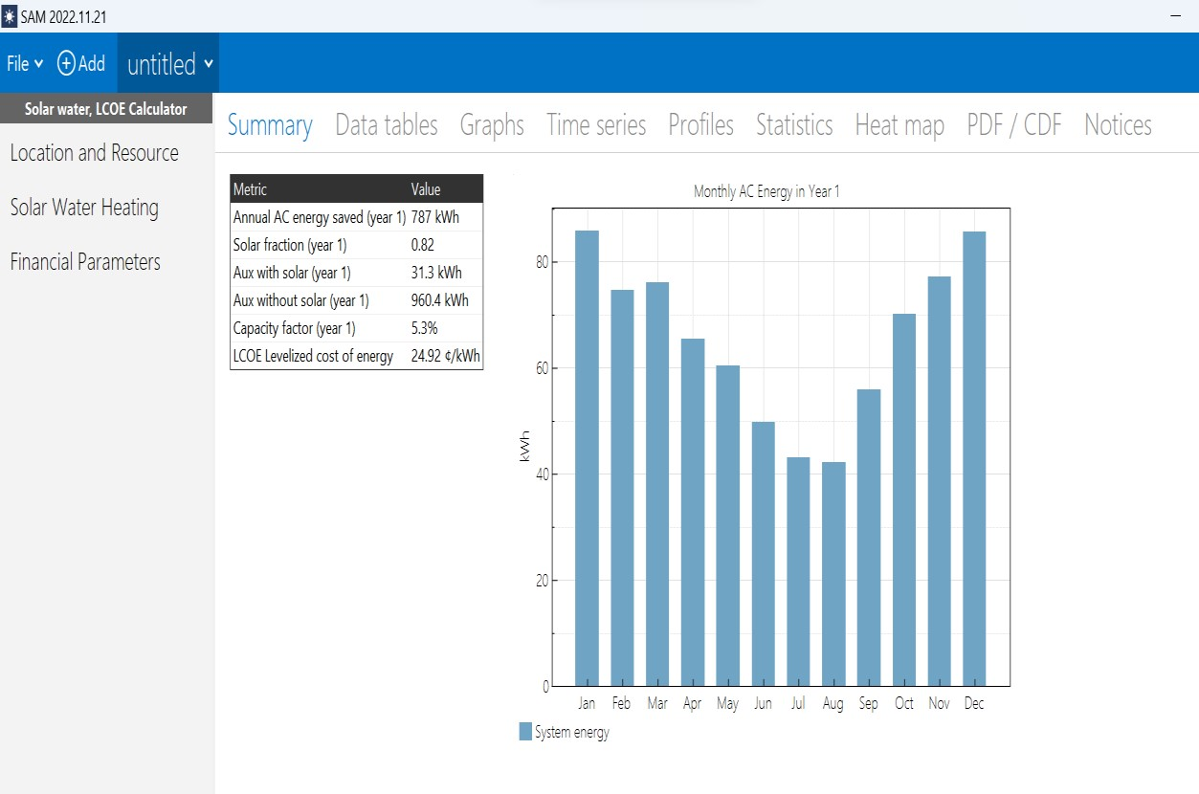

Demand: 150 l/day

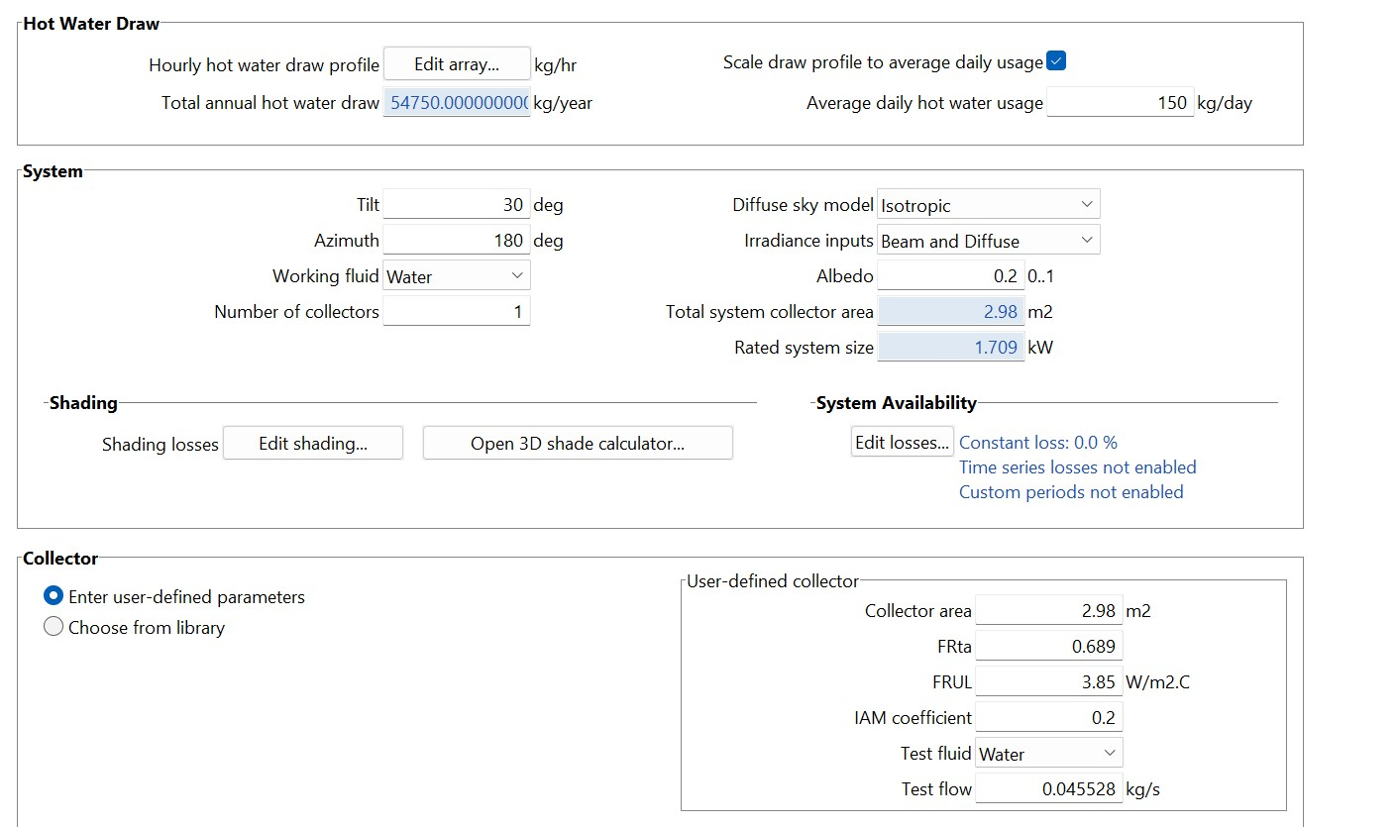

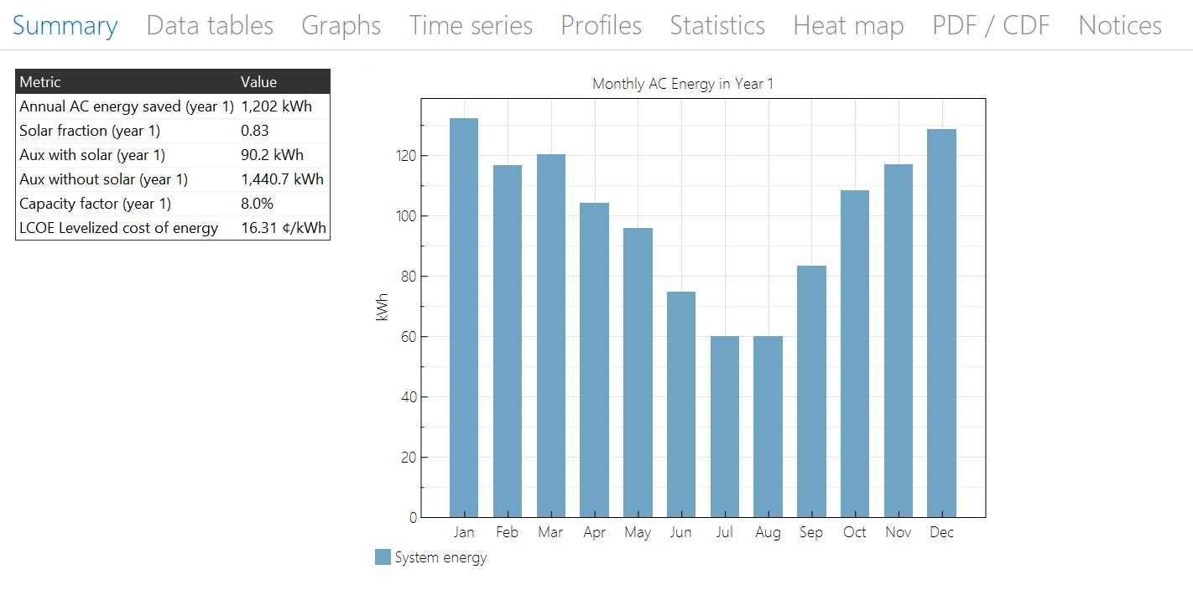

Demand: 200 l/day

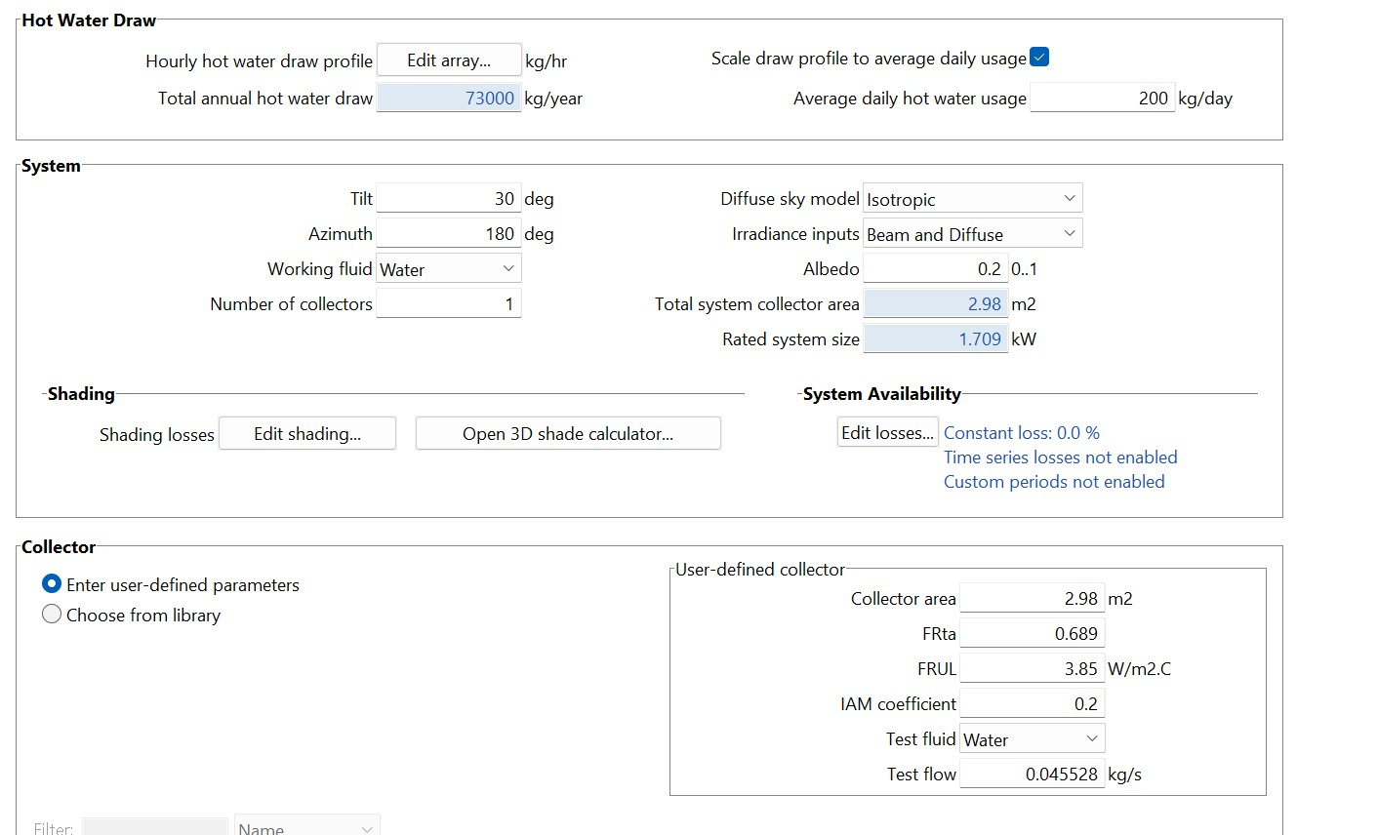

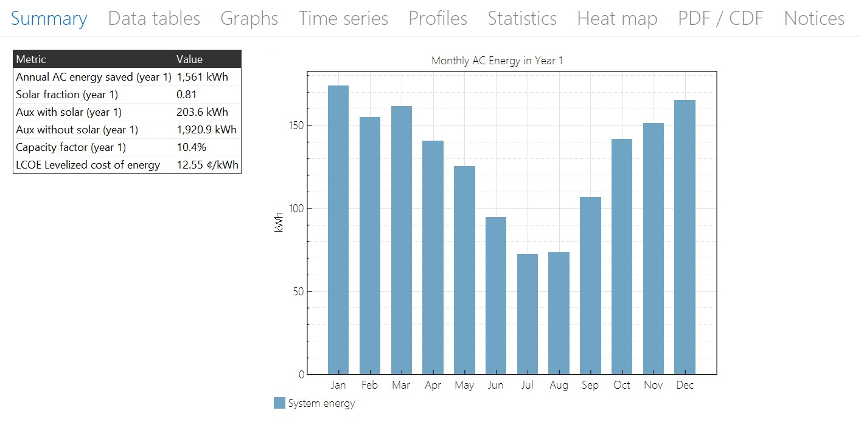

Demand: 250 l/day

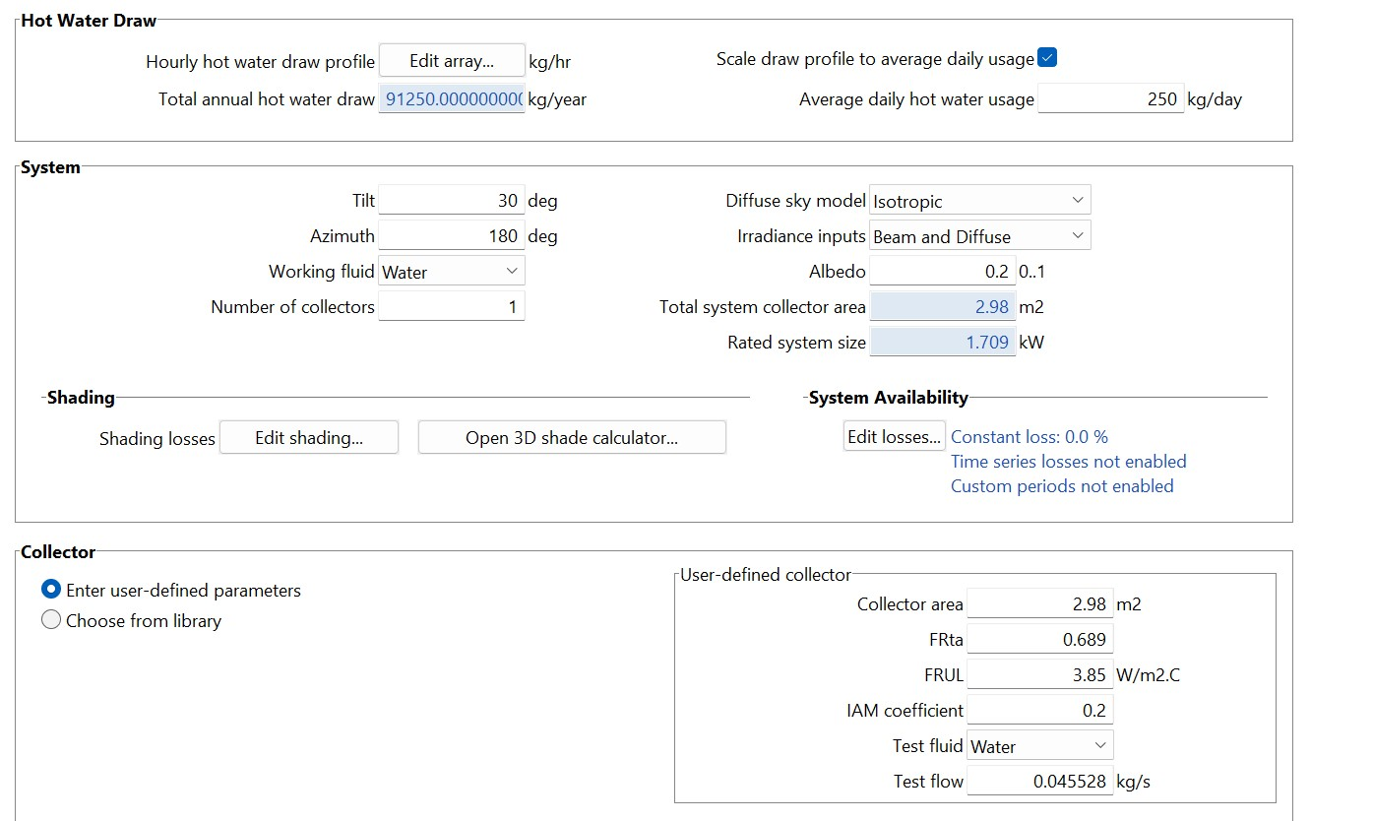

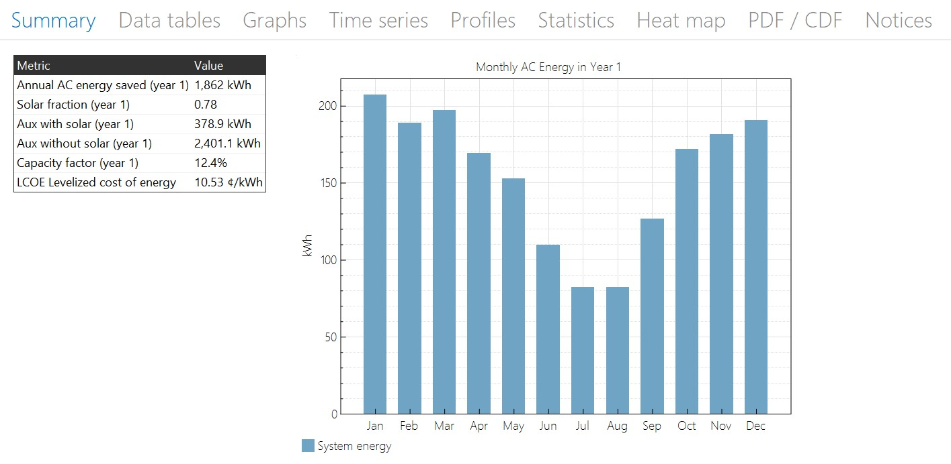

Demand: 300 l/day

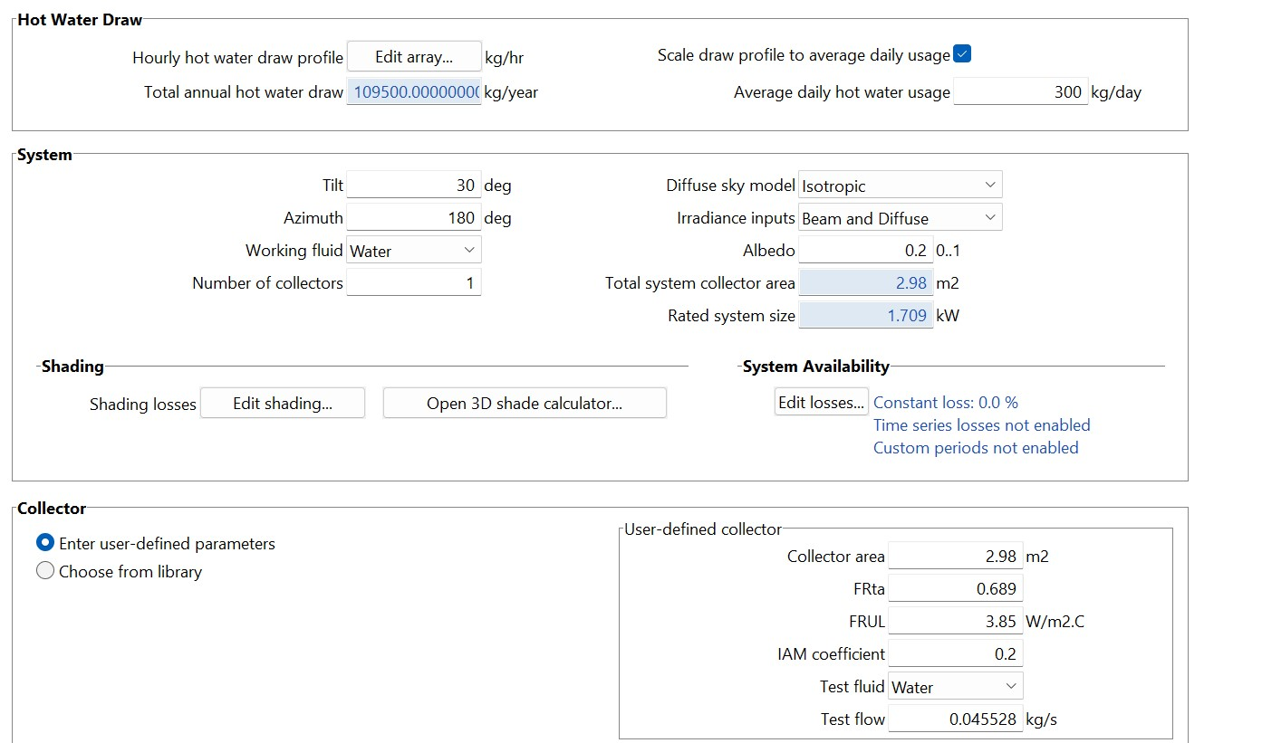

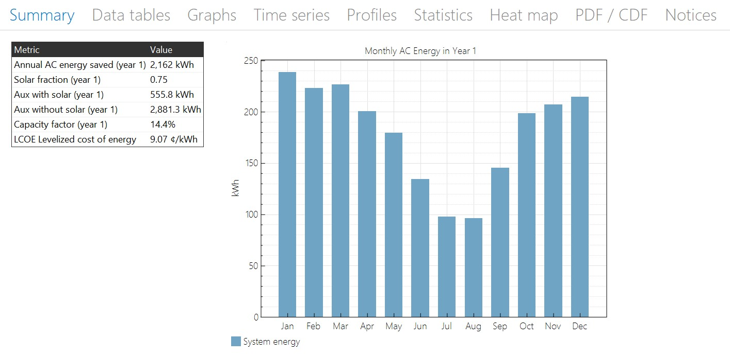

**Comparison Analysis:**

|  |  |  |  |  |
| --- | --- | --- | --- | --- |
| Water Demand | LCOE | CF | Annual Energy  Saved |  |
| 50 l/day | 58.11 | 2.3% | 337 kWh |  |
| 100 l/day | 24.92 | 5.3% | 787 kWh |  |
| 150 l/day | 16.31 | 8.0% | 1,202 kWh |  |
| 200 l/day | 12.55 | 10.4% | 1,561 kWh |  |
| 250 l/day | 10.53 | 12.4% | 1,862 kWh |  |
| 300 l/day | 9.07 | 14.4% | 2,162 kWh |  |

**Annual Energy Saved:**

The information pertains to the performance analysis of a solar water heater within Bhavnagar, using the Levelized Cost of Energy (LCOE) calculator integrated with SAM (System Advisor Model) software. The LCOE calculator evaluates the expense of producing a unit of energy throughout the lifecycle of the solar water heating system, considering factors like initial outlay, upkeep, and energy generation.

Here are the energy savings corresponding to various water demand levels:

• For a daily water requirement of 50 liters: 337 kWh of annual energy preservation.

• For a daily water requirement of 100 liters: 787 kWh of annual energy preservation.

• For a daily water requirement of 150 liters: 1202 kWh of annual energy preservation.

• For a daily water requirement of 200 liters: 1561 kWh of annual energy preservation.

• For a daily water requirement of 250 liters: 1862 kWh of annual energy preservation.

• For a daily water requirement of 300 liters: 2162 kWh of annual energy preservation.

Evidently, as the demand for water increases, the solar water heater's capacity to generate and supply heated water assumes greater significance, resulting in escalated energy savings annually. The magnitude of annual energy preservation also witnesses a substantial rise. This highlights the efficiency of harnessing renewable solar energy to fulfill a substantial portion of hot water requirements, leading to reduced dependence on conventional energy sources and consequential financial advantages.

In essence, the furnished data underscores the efficacy and proficiency of solar water heaters within Bhavnagar. The correlation between typical daily hot water consumption and the yearly energy conserved showcases the technology's potential to contribute to energy efficiency, financial savings, and ecological sustainability. This dataset holds valuable insights for those interested in adopting solar energy for water heating applications within the region.

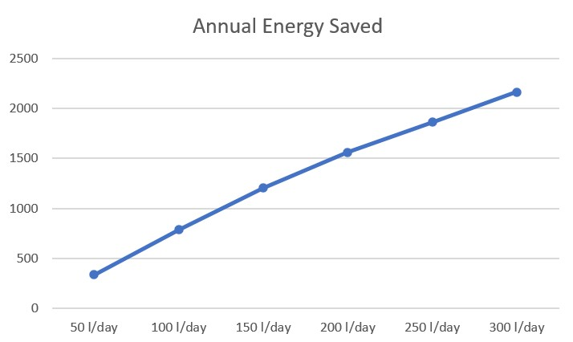

**Levelized Cost of Energy (LCOE):**

The data yielded by the LCOE calculator within the SAM software for a solar water heater situated in Bhavnagar city presents a comprehensive view of the Levelized Cost of Energy (LCOE) across varying levels of average daily hot water consumption. This data is instrumental in shedding light on the economic viability of integrating solar water heating technology. Several notable takeaways emerge from this dataset:

• The data unequivocally portrays an inversely proportional connection between the average daily hot water utilization and the LCOE pertaining to the solar water heater. As the demand for water escalates, the LCOE experiences a marked decline. This signifies that generating energy units through the solar water heater becomes more cost-efficient as hot water requirements increase.

• The declining LCOE trend linked with amplified water demand implies the presence of economies of scale. This suggests that as system dimensions and energy output expand, the average expense of energy production diminishes. Consequently, larger solar water heating systems offer enhanced cost-effectiveness.

• The reduced LCOE figures associated with greater water demands underscore the heightened economic appeal of larger-scale solar water heaters. This accentuates how solar water heating systems gain financial traction as their scale amplifies, accompanied by augmented energy generation.

• The diminishing LCOE underscores the critical importance of sizing solar water heater systems meticulously, aligning with the precise hot water needs of users. Proper system sizing aligning with demand can lead to superior cost savings over the system's operational life span.

• The decreasing LCOE also underscores the enticing financial gains associated with investing in solar water heating technology. Beyond reducing energy expenditures, this technology contributes to carbon emissions reduction by harnessing renewable energy for water heating purposes.

• The dataset proves invaluable for individuals, enterprises, and policy shapers contemplating the integration of solar water heaters. It brings to the fore the fiscal efficiency of larger systems while encouraging meticulous assessment of system dimensions in accordance with water demand.

To conclude, the furnished data distinctly highlights the economic viability of solar water heaters in Bhavnagar. The descending trajectory of LCOE with ascending water demand underscores the potential for considerable financial savings and lends impetus to the assimilation of solar water heating technology. This dataset stands as an indispensable guidepost for informed decision-making regarding investments in solar water heaters, encompassing considerations like system sizing, energy preservation, and enduring fiscal advantages.

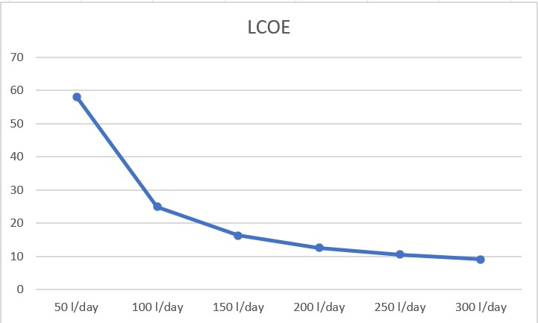

**Capacity factor:**

The data extracted from the LCOE calculator in the SAM software, pertaining to a solar water heater in Bhavnagar, and revealing the Capacity Factor across various levels of average daily hot water consumption, yields insights into the efficiency and deployment of solar water heating technology. The ensuing observations can be made based on the provided data:

• The dataset illustrates a linear correlation between the average daily hot water usage and the Capacity Factor exhibited by the solar water heater. With an increase in water demand, the Capacity Factor experiences a proportional rise.

• The Capacity Factor denotes the ratio between the actual energy output and the maximum conceivable energy output of the system. For solar water heaters, it functions as a gauge of how adeptly the system satisfies the hot water requirement. Elevated Capacity Factors indicate more proficient usage of the system.

• The escalating pattern in the Capacity Factor as water demand climbs signifies that solar water heaters perform at an elevated level of efficiency when addressing substantial hot water needs. This suggests that larger systems are more adept at catering to energy requirements and producing a noteworthy segment of the necessary hot water, thereby culminating in higher Capacity Factors.

• Elevated Capacity Factors serve as indicators of well-designed systems capable of effectively harnessing solar energy, which, in turn, translates into enhanced energy savings.

• In sum, the provided dataset accentuates the correlation between the average daily hot water usage and the Capacity Factor within the domain of solar water heaters in Bhavnagar. The rising Capacity Factor alongside amplified water demand underscores the greater efficacy and competence of larger systems in meeting hot water requisites. This data furnishes valuable insights for those contemplating the integration of solar water heating technology, underscoring the merits of appropriately sizing the system for optimal energy utilization and cost efficiency.

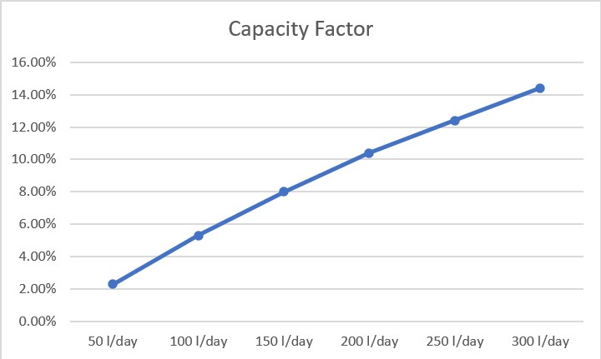

**For 2 collectors:** Demand: 300 l/day

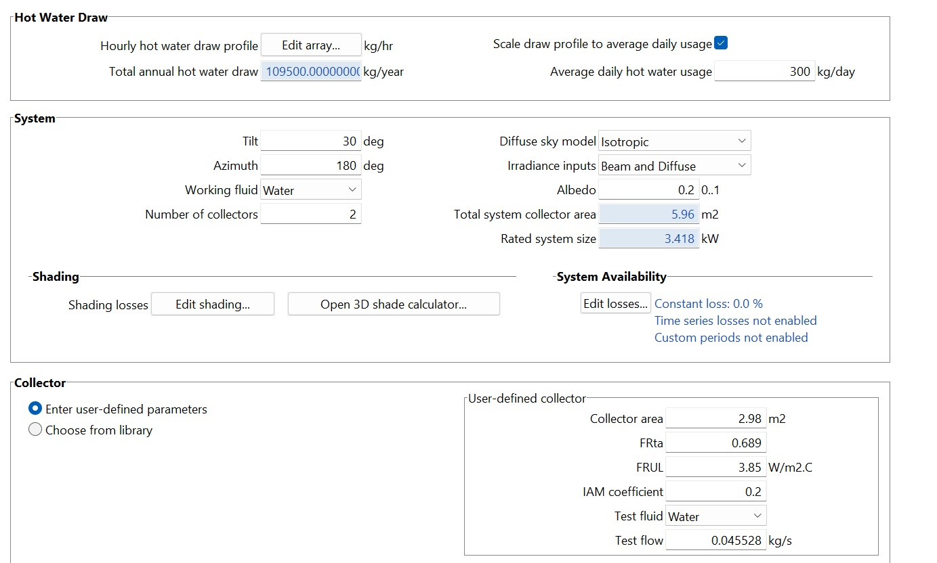

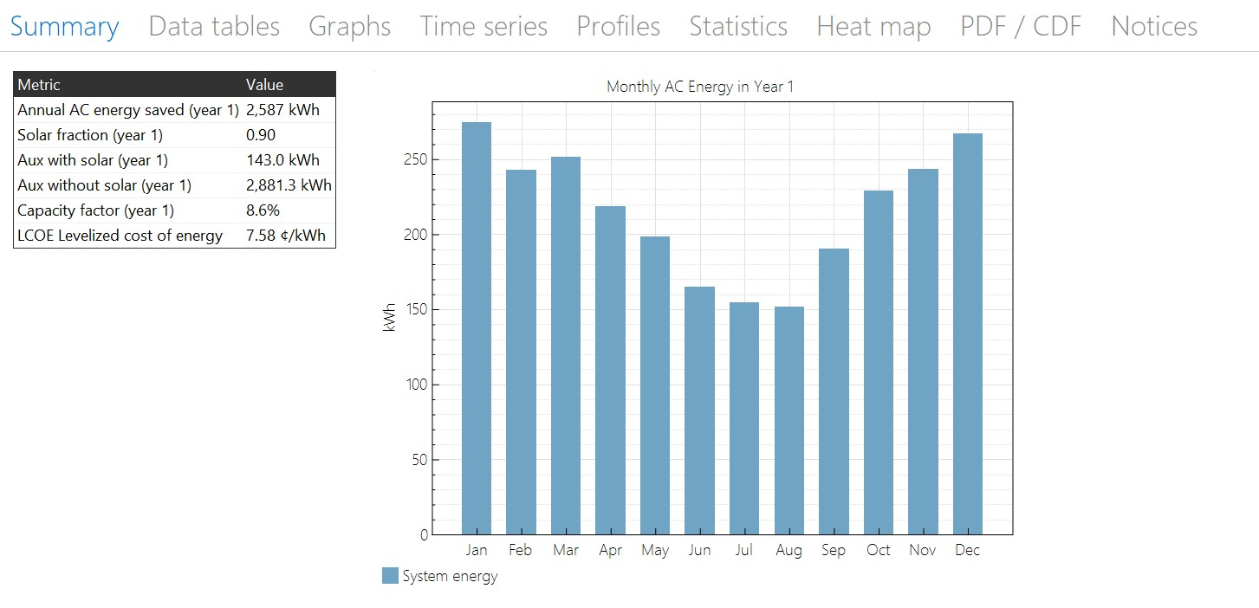

**Comparison Analysis:**

|  |  |  |
| --- | --- | --- |
|  | 1 Collector | 2 Collectors |
| LCOE | 9.07 | 7.58 |
| CF | 14.4% | 8.6% |
| Annual Energy Saved | 2162 kWh | 2,587 kWh |

The provided information outlines a comparative examination involving two distinct solar water heater setups in Bhavnagar city, with computations carried out utilizing the SAM (System Advisor Model) software. These configurations differ based on the count of collectors employed. Here is an overview of the comparative analysis derived from the supplied data:

**LCOE (Levelized Cost of Energy):**

Configuration with 1 Collector: LCOE of 9.07

Configuration with 2 Collectors: LCOE of 7.58

**Analysis:** In the context of the provided data, the setup featuring 2 collectors exhibits a decreased LCOE in contrast to the configuration with just 1 collector. This discrepancy implies that the system equipped with 2 collectors holds greater cost-efficiency in generating energy units throughout its operational lifespan. The lower LCOE value signifies enhanced economic feasibility and potentially swifter recuperation of investment outlay.

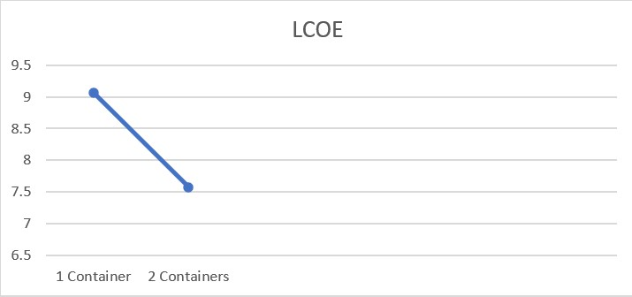

**Capacity Factor (CF):**

Configuration with 1 Collector: CF of 14.4%

Configuration with 2 Collectors: CF of 8.6%

**Analysis:** The setup encompassing 1 collector showcases an elevated Capacity Factor when juxtaposed with the configuration incorporating 2 collectors. This augmented Capacity Factor signifies that the system featuring 1 collector harnesses available solar energy more adeptly. This could be attributed to factors such as improved alignment with solar angles, diminished shading influences, or a more efficient design of the collector.

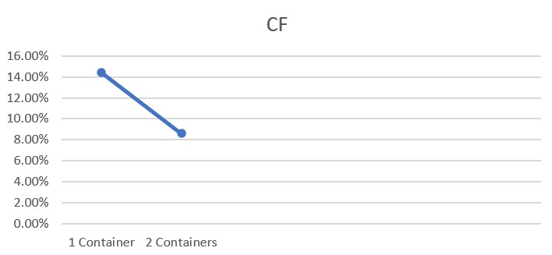

**Annual Energy Saved:**

Configuration with 1 Collector: 2162 kWh

Configuration with 2 Collectors: 2587 kWh

**Analysis:** The setup incorporating 2 collectors yields augmented annual energy savings when juxtaposed with the configuration comprising 1 collector. This amplified energy conservation correlates with the lower LCOE observed in the system featuring 2 collectors. This correspondence underscores that the supplementary collector leads to heightened energy generation and more efficient harnessing of solar energy.

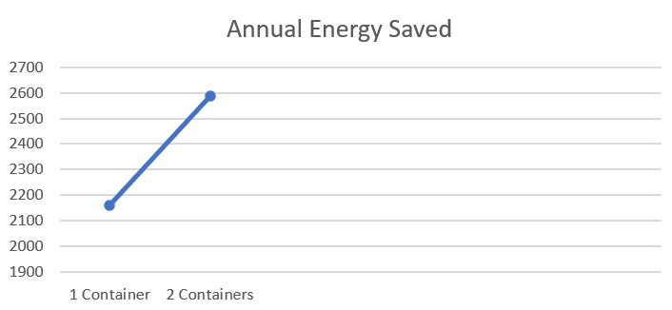

**Conclusion:**

The configuration featuring 2 collectors surpasses the performance of the setup comprising 1 collector in terms of both LCOE and yearly energy preservation. This observation implies that employing a greater number of collectors results in enhanced economic viability and elevated energy yield, consequently fostering improved financial savings over the system's operational lifespan. Nevertheless, it is imperative to consider the initial investment and installation expenses associated with incorporating supplementary collectors when formulating decisions concerning system configuration.

The heightened Capacity Factor exhibited by the system possessing a single collector intimates that the design or alignment of the single collector configuration might be meticulously optimized for capturing solar energy. Therefore, while the system outfitted with 2 collectors boasts superior energy output, in-depth analysis might be requisite to comprehend factors influencing collector efficiency and long-term cost-effectiveness. This underscores the need for a comprehensive evaluation of the entire cost-to-benefit equation before arriving at informed decisions regarding collector quantity and overall system setup.